Lockdown Extraction thumb drive:

1. Format a thumb drive with the volume label “Lockdown”. (No Quotes, but make sure the L is cap)
2. Place the three files/directories on it; 1) Lockdown.app, 2) Mac_Lockdown directory, and 3) Windows Lockdown.bat

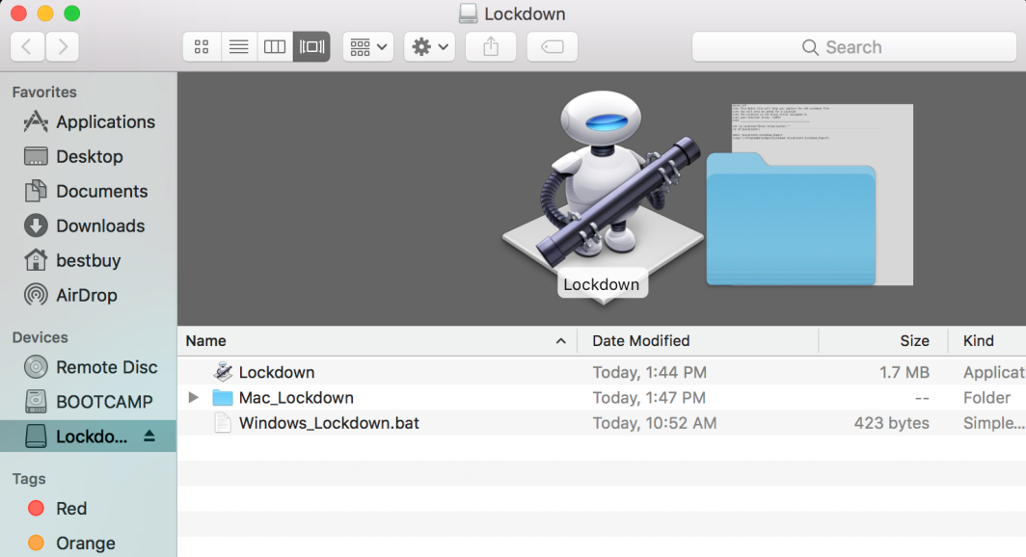

# Mac OSX:

1. Insert thumb and launch the Lockdown application.
2. You will be prompted for Administrator Privileges, enter the credentials.

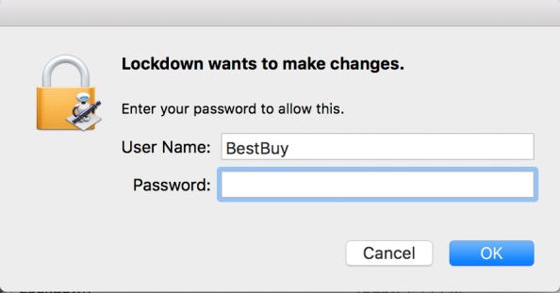

1. The application will do the rest.
2. Rename the copied lockdown folder with information related to the computer. For example, “17-1234_Neemann_MacBook_Pro_Lockdown_02222017”.
   1. The renaming is important as the copy process with maintain the same lockdown directory name on any computer.
3. The application can now be run again on another computer.

# Windows:

1. Right click on the “Windows_Lockdown.bat” file and select “Run as administrator”

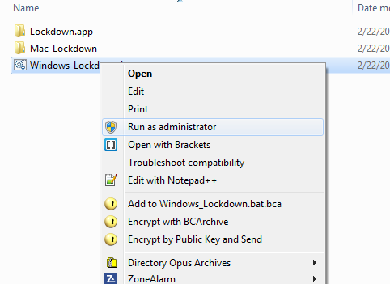

1. Then type in the drive letter of the thumb drive which contains the batch file. (Make the letter Caps)

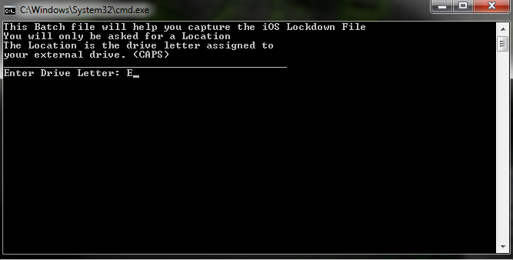

1. The batch file will copy the contents of the lockdown directory to a “Lockdown_Export” file on the thumb drive.
2. Rename the copied lockdown folder with information related to the computer. For example, “17-1234_Neemann_Dell_Laptop_Lockdown_02222017”.
   1. The renaming is important as the copy process with maintain the same lockdown_export directory when run on another computer.
3. The application can now be run again on another computer.